**Thurston County Water Resources**

**Technical Memorandum #7**

Prepared by

Nathaniel Kale

Water Resources Specialist II

Thurston County, Washington

DOI XXXX

January 18, 2017

Lake St. Clair Water Elevation  
1992-2016

# Background

Lake St. Clair is a lake in east-central Thurston County, fed by Eaton Creek which flows from south to north.

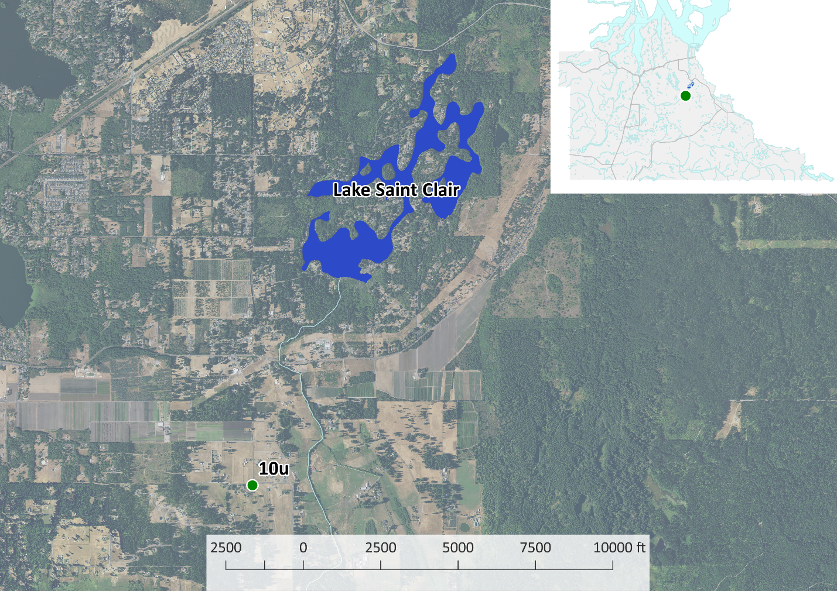

Its irregular shoreline is densely populated with single family homes. Over several decades the elevation of the lake has fluctuated between approximately 65 and 71.5 feet above mean sea level. This fluctuation, in the form of rising water levels since 2005, has residents concerned about losing their shoreline and property.

Since 1988 Thurston County and the City of Olympia have collected data on the elevation of Lake St. Clair. Thurston County has collected precipitation data at a nearby station (Eaton Creek, also known as 10u and PEA1) since 1992. The National Oceanic and Atmospheric Administration (NOAA) has collected precipitation data at the Olympia Airport since 1955. Together, these data can be used to evaluate trends, correlations, and potentially causal factors between precipitation and lake elevations.

This technical memorandum compares precipitation and lake level data using a variety of methods. The memorandum also recommends additional methods for utilizing existing data, and recommends additional data that could improve understanding of the hydrology of the lake.

# Results

**Lake St. Clair water elevation displays a clear annual cycle**, rising during the wet season and lowering during the dry season by about 2 feet over the course of the year. It also displays a long-term trend of rising and falling over the past 30 years, which account for at least as much of the variation in elevation as the seasonal variation. These long term trends have varied since measurement began in 1988, but **since at least 2005 the overall trend has been an increase in water level of about 3 feet**.

Figure : Water Elevation Decomposition

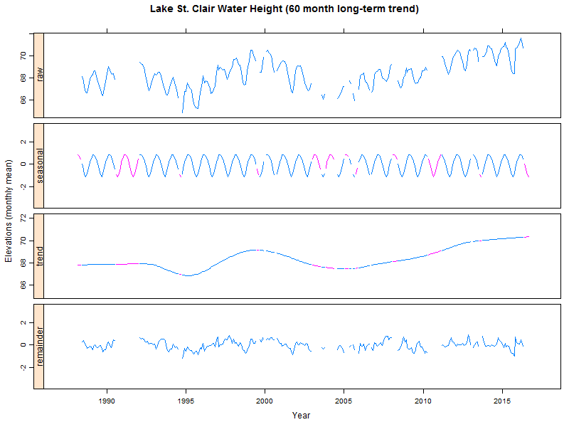

Note that in Figure 1, missing data in the “seasonal” and “trend” series are in pink; those values are estimated, whereas values in blue are derived directly from the data.

In Figure 2, three measures of precipitation appear to explain a significant (just over 55%) amount of the variation in lake elevations: cumulative precipitation over a 6 month period, cumulative precipitation over a 42 month (3.5 year) period, and long-term precipitation intensity. The two separate cumulative rainfall measures encompass both annual fluctuations and longer-term trends, but don’t appear to explain all of the variation in lake elevation, especially since 2005. Long-term rainfall intensity seems to match long-term lake elevation variation since about 1995.

Together, these data suggest that **Lake St. Clair is probably more strongly influenced by surface water hydrology than ground water hydrology**. Seasonal precipitation patterns drive short-term fluctuations, indicating that water quickly moves from where it falls to the lake via surface or near-surface flow. Precipitation intensity varies positively with lake elevations (as intensity increases, elevations increase, and vice versa); more intense rainfalls tend to generate more surface runoff than storms with similar volumes over longer periods.

Figure : Water Elevation Correlation with Precipitation

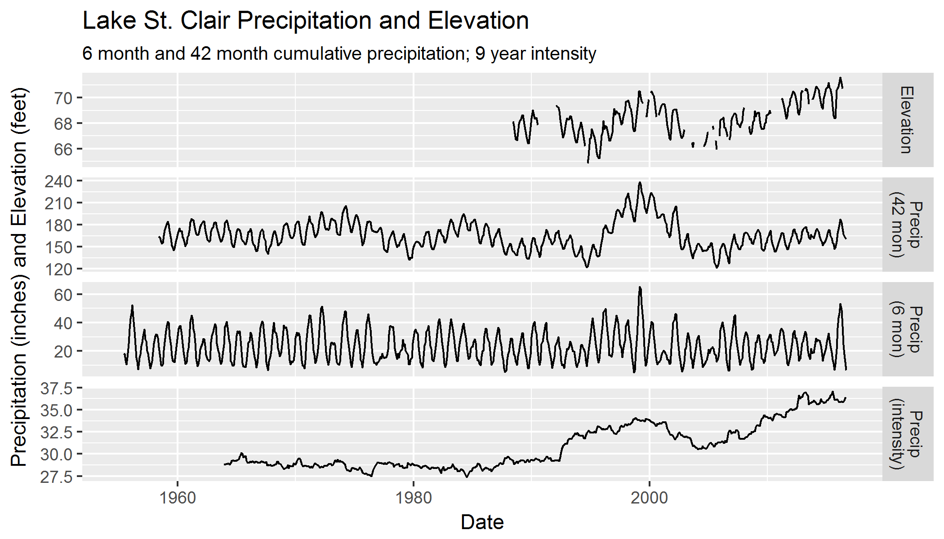

# Methods

## Software

This analysis was conducted in R 3.3.1 (RStudio 1.0.44, plus packages dplyr, ggplot2, lubridate, readr, stlplus, zoo); QGIS 2.14; Excel 2013; and Notepad++ 7.1.

## Data

Daily precipitation data were acquired from NOAA for the Olympia Airport site extending back to 1955. Daily precipitation data for the Eaton monitoring site from 2004-2016 were available in the Thurston County monitoring archive. Data from the PEA1 monitoring site (the same site as Eaton, also known as 10u) from 1992-2000 were also available from Thurston County archives (see Thurston County Water Resources Technical Memorandum #6 for details).

Elevation data for Lake St. Clair were also obtained from Thurston County monitoring archives. Daily values from 2008-2016 were available; from 1988-2008, monthly minima and maxima were available, with some breaks in the data.

All data are monthly. Total precipitation values are total inches per month (sum of all rainfall in a month). Precipitation intensity values are a unitless measure of maximum daily precipitation in a month divided by the sum of monthly precipitation. Elevation values are monthly averages; prior to 2008 these are averages of minima and maxima; after 2008 these are averages of daily values.

## Analysis

This exploratory analysis included:

* Extending and filling the 10u precipitation record.
* Decomposing the rainfall and lake elevation records.
* Calculating cumulative precipitation and precipitation intensity.
* Comparing precipitation records (raw, cumulative, and intensity) to lake elevation records.

## Extending and Filling Precipitation

The most complete daily precipitation record in Thurston County is the NOAA gaging station at the Olympia Airport. Since 1992 Thurston County has operated the Eaton (also 10u or PEA1) precipitation station in the Eaton Creek/Lake St. Clair watershed. The Eaton station does not have a complete record over the Lake St. Clair elevation record, but because it is in the Lake St. Clair watershed it better represents precipitation in areas that drain to the lake.

The 10u daily precipitation record was extended by establishing a relationship with the NOAA daily precipitation using linear regression. Original measured values from Eaton were retained, while missing values (including gaps in the dataset, precipitation values prior to 1992, and data dropped because they were flagged as poor quality) were filled with the values predicted by the relationship with the NOAA gage.

Figure : Eaton (10u) Precipitation

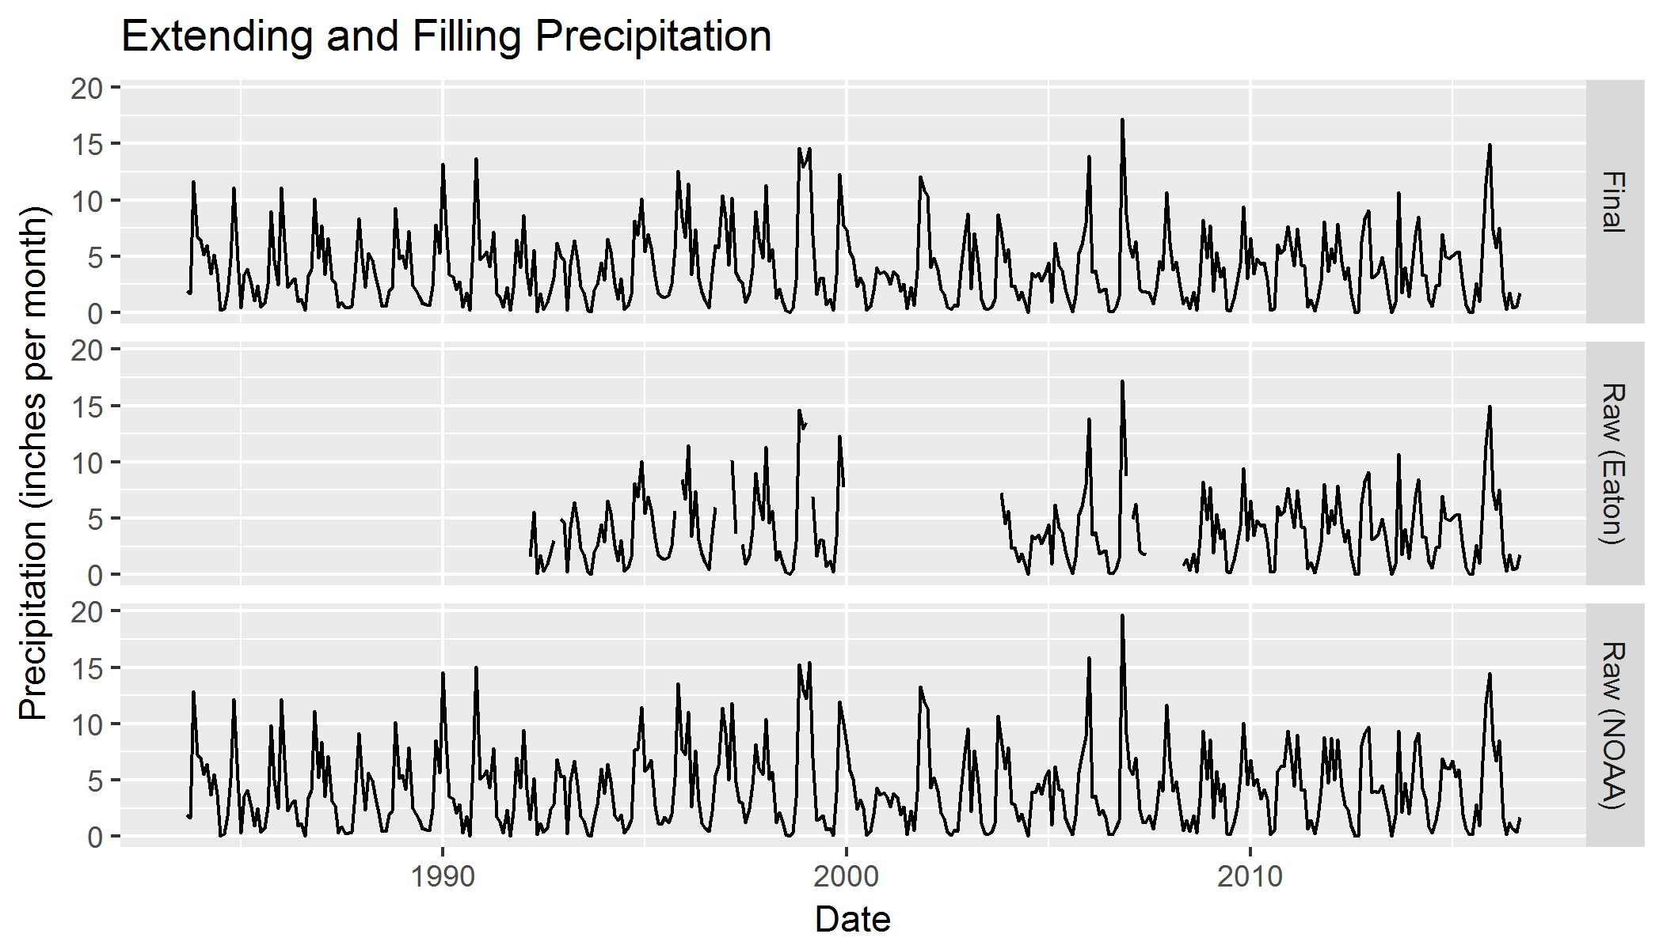

Monthly precipitation values were calculated by summing the daily filled and extended precipitation record. The final merged precipitation dataset extended the full duration of the NOAA dataset, from 1955 to late 2016, but for most analyses was truncated at 1977 because the Lake St. Clair gage data only extends to 1988.

## Decomposing Trends

Both rainfall and lake elevations vary over time with the season, and in response to longer-term trends. It is possible to “decompose” a time series into seasonal, trend, and remainder components that, when added together, recreate the original series. This process of decomposition is called STL, or Seasonal and Trend Decomposition using Loess (Cleveland, Cleveland, McRae, & Terpenning, 1990).

Figure : Precipitation Decomposition

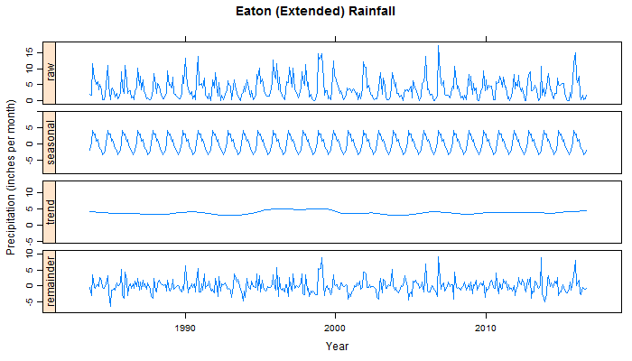

Rainfall has an obvious seasonal pattern, rising and falling over the course of a year. The long-term trend, in this case calculated over a 3.5 year (42 month) window, is important, but explains very little of the variation in the data (note that the y axes on all four graphs are set to the same scale, though with different minima); this memorandum addresses long-term trends later.

Much of the “raw” precipitation is explained by the remainder, meaning that seasonal and long-term trends have limited ability to explain precipitation variation over time. This is an expected result – climate is fairly consistent, but weather is unpredictable.

Figure : Lake St. Clair Water Elevation Decomposition

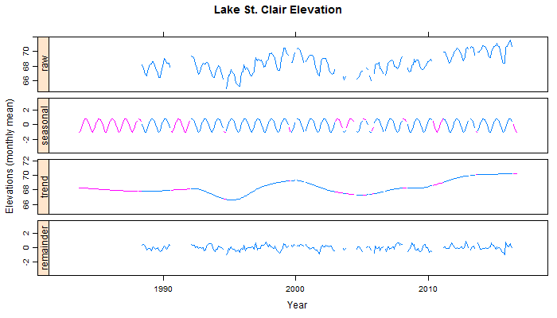

In Figure 5, blue indicates values calculated directly from the data, while pink/purple indicates values that were extrapolated based on neighboring values. Note that while the seasonal and trend graphs are extended and gap-filled, no attempt was made to estimate a remainder where there are no raw elevation values.

As with the precipitation decomposition, a yearly cycle is clearly evident in the seasonal water elevation trend. Unlike the precipitation decomposition, the long-term trend (again calculated over a 3.5 year window) explains a great deal of the variation. The remainder is relatively small, suggesting that seasonal and long-term effects are the primary influences on lake elevations.

There are strong and similarly-shaped seasonal trends in both the lake elevation and precipitation data, suggesting that most of the annual cycle in lake elevations can be explained by the matching annual cycle in precipitation. Long-term trends are different, however. It is difficult to see from Figure 4 and Figure 5 whether there’s a strong relationship between the long term precipitation and water elevation trends.

Figure : Long-term Trends

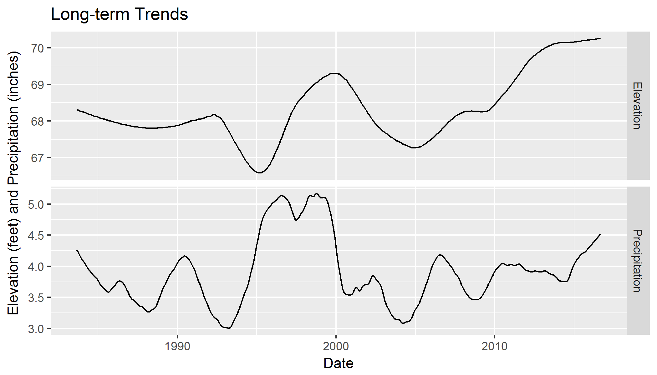

Figure 6 shows the long term trends of both lake elevation and local precipitation. While there are some similarities between the long-term trends, there are a lot of differences, as well. Both series have extended “bumps” or “hills” in the 1995-2002 range, but the shape of the bumps is different, and they are shifted relative to one another (the precipitation bump begins and ends earlier than the elevation bump). Both show a generally increasing trend from approximately 2005 to the present, but the elevation trend is stronger and more consistent than the precipitation trend.

Overall, the decomposition analysis of precipitation and Lake St. Clair water elevation tells us:

* Lake elevation can be explained almost entirely by yearly cycles and long-term trends;
* Annual lake elevation cycles are strong, and match equally strong annual precipitation cycles; and
* Long-term trends in precipitation data are weak, and appear to only loosely match long-term lake elevation trends.

## Cumulative Precipitation and Precipitation Intensity

Two things can change lake elevations: changes to the hydrology of the watershed, such as new sources or discharges of water; and changes to precipitation. While the annual lake elevation cycle is well explained by annual cycles in precipitation, the long-term trend in raw precipitation values does not explain the long term trend of Lake St. Clair elevations. Changes to the hydrology could explain the difference, or there could be changes to precipitation that are not apparent through time-series decomposition.

**Cumulative precipitation** is one way to measure changes to precipitation over time. It is the sum of all precipitation over a defined period. Each point in the series contains the sum of the preceding months’ rainfall for the entire defined period. This is sometimes referred to as a “moving window”. Figure 7 shows raw vs. cumulative rainfall for a 6 month moving window.

Figure : Example Cumulative vs. Raw Precipitation

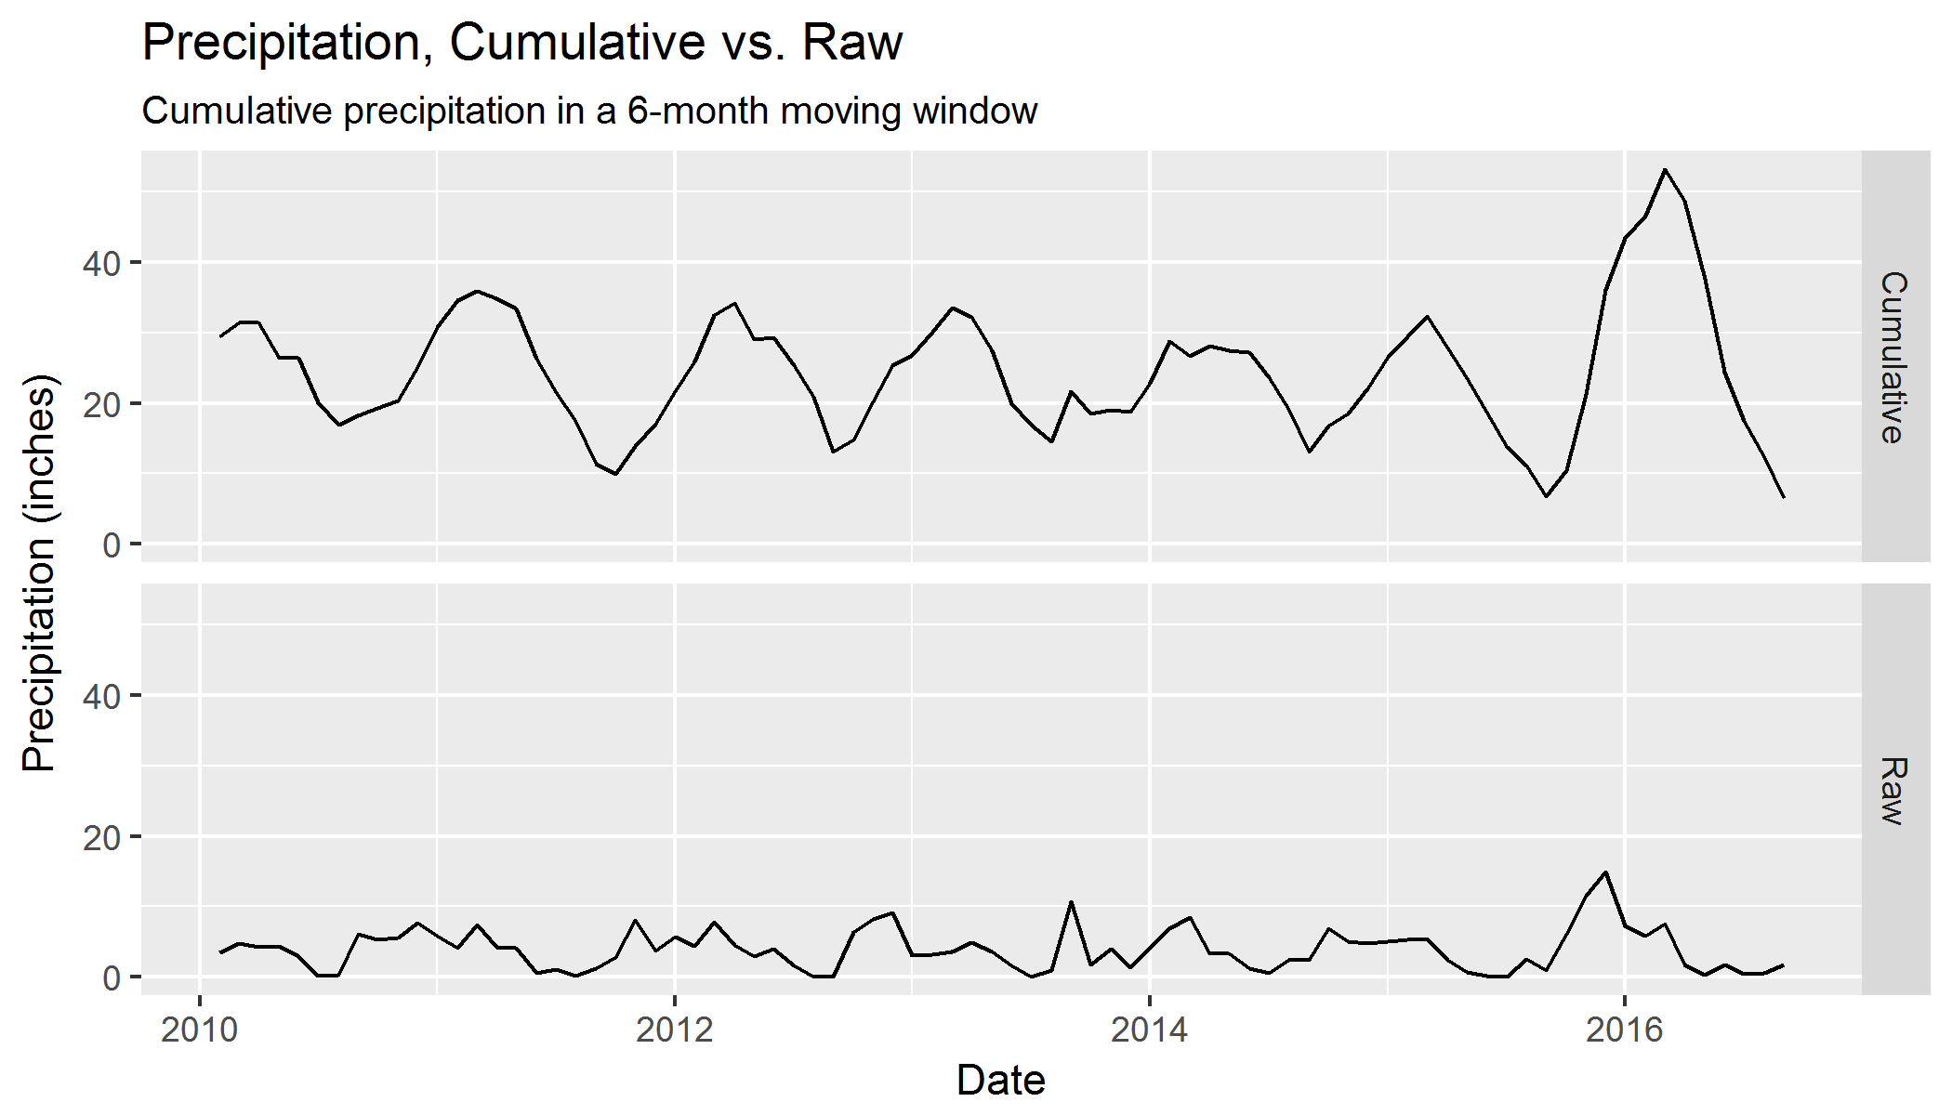

Note that using a 6 month window (or any multiple thereof) tends to magnify seasonal trends. Using a 12-month window (or any multiple thereof) would tend to flatten seasonal trends instead.

**Precipitation intensity** is a measure of how precipitation is distributed over time. Two months might have the same total volume of precipitation but differing intensities, if precipitation in one month is spread across multiple days or weeks while precipitation in the other occurs during a single day.

For this analysis, intensity was calculated for each month by dividing the maximum rainfall in the month by the sum of rainfall in the month. The resulting series was a unitless measure where higher values meant greater intensity[1].

Cumulative rainfall intensity was also calculated over multiple moving window periods.

## Comparing Precipitation to Elevation

A relationship was created between the elevation of Lake St. Clair and three derived series from precipitation: 6-month cumulative precipitation, 42-month cumulative precipitation, and 9-year (108-month) cumulative precipitation intensity.

The best periods (moving windows) for **cumulative precipitation** were calculated by comparing the results of linear regressions against elevations for periods of 1 to 96 months.

Figure : R Squared of Cumulative Precipitation Periods vs. Elevation

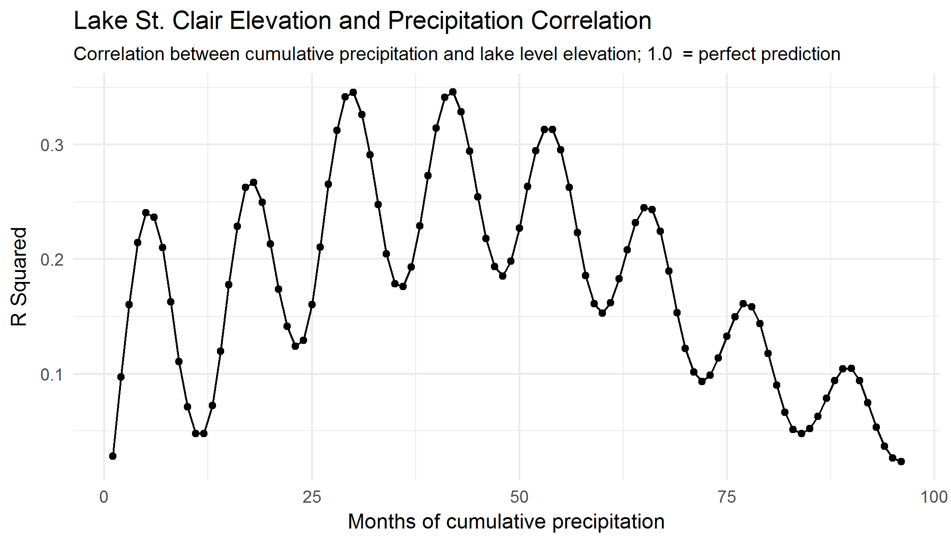

Each point in Figure 8 represents the number of preceding months included in the cumulative precipitation on the x axis, with the correlation between cumulative precipitation and Lake St. Clair elevations on the y axis. This correlation is measured as the R Squared, or R2, of a linear regression between the two series, with each dot corresponding to a different regression.

The figure shows that there are two trends working in concert on the correlation between precipitation and elevation. The first is an annual cycle. As the total number of months of cumulative precipitation approaches a multiple of 12 plus or minus 6 (e.g., 6, 18, 30, 42), the R2 increases. As the total number of months approaches a multiple of 11 or 12, the R2 decreases. This is an indication that cumulative rainfall that amplifies seasonal trends (see Figure 7) is more directly related to lake elevation than cumulative rainfall that smooths over seasonal trends. In other words, annual precipitation cycles roughly match annual lake elevation cycles.

The second trend in Figure 8 is a gradual rise then gradual fall in the R2 value over the entire series, from 1 to 96. The highest R2 values are at 29, 30, 41, and 42 months – three or four years plus 5 or 6 months. The best possible relationship with lake elevations, which accounts for both seasonal variations and long-term trends, is cumulative rainfall over one of those four windows.

The best R2 value in Figure 8 is approximately 0.35, meaning 35% of the variation in lake elevation is explained by cumulative rainfall.

Nearly the same procedure was performed by looking at many possible values of total months of **cumulative precipitation intensity**. For this procedure, the 42-month cumulative precipitation series was used as one of the two terms in the linear regression. In R code:

regression = lm(elevation ~ + 42_month_cumulative + X_month_intensity)

where X is a value from 48 to 156.

Figure : R Squared of Cumulative Precipitation Intensity Periods vs. Elevation

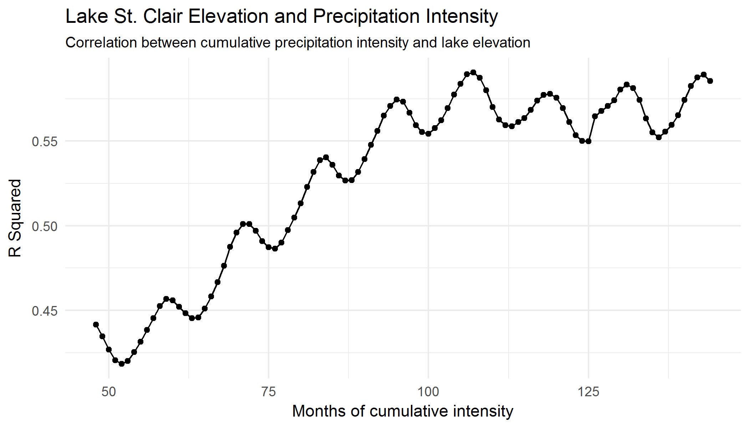

Figure 9 shows an annual cycle, much like Figure 8. One key difference is that the cycles peak around multiples of 12 (60, 120, etc.), rather than multiples of 12 + 6 as they do in Figure 8. Because accumulations that are multiples of years tend to flatten out seasonal cycles, this indicates that seasonal variations in precipitation intensity do not correlate well with seasonal variations in lake elevation.

Also like Figure 8, Figure 9 has a second trend across the entire graph of increasing to a peak around 108 months (9 years), and plateauing after that. This indicates that nine full years of cumulative rainfall intensity help explain a significant amount of the variation in long-term changes to lake elevations.

With the cumulative rainfall and rainfall intensity values in the same model, the maximum R2 value is approximately .59, or 59% of the variation in lake elevation explained by the three variables.

## Final Analysis

About 59% of the variation in the elevation of Lake St. Clair can be explained by a linear regression with 6-month cumulative precipitation, 42-month cumulative precipitation values, and 108-month cumulative precipitation intensity values:

regression = lm(elevation ~ 6_month_cumulative + 42_month_cumulative + 108_month_intensity)

Figure : Lake Elevations and Precipitation Factors

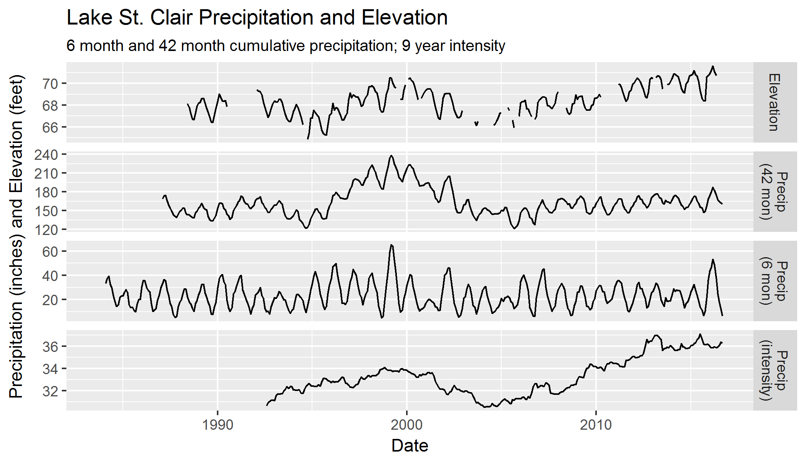

Figure 10 shows how each of the three variables helps explain variation in Lake St. Clair’s elevation. 42-month cumulative precipitation includes both seasonal trends and long-term variability, but seasonal variability doesn’t match perfectly, and the long-term trend doesn’t fully explain some of the change in elevation. For example, the 2005-present long-term trend for 42-month cumulative precipitation is not as steep as the elevation trend over the same time period. 6-month cumulative precipitation captures seasonal variation well, but nothing else. Precipitation intensity captures long-term variability and no seasonal variation, but isn’t a perfect match for the long-term trend in elevation. The trend from 2005-present is steeper in precipitation intensity than show in measured lake elevation.

# Conclusions and Recommendations

## Conclusions

Lake St. Clair water elevations are driven by seasonal variation and long-term trends. Over half of that variation can be explained by changes in cumulative precipitation (both seasonal and over multiple years), and long-term trends in precipitation intensities.

Almost half of the variation in Lake St. Clair water elevations cannot be explained by the precipitation values explored in this memorandum. Hydrologic processes are often more complex than the relatively simple linear regressions used in this analysis can capture. It is possible that even more of the variation in Lake St. Clair elevations could be explained by a complete hydrologic model.

A primary concern of residents around Lake St. Clair is rising lake levels since 2005. It is likely that at least some of that change has been driven by changes in precipitation. Rainfall intensity, in particular, seems to correlate (albeit imperfectly) with rising lake elevations over the past 12 years.

Water elevations in Lake St. Clair seem to be dominated more by short- and medium-term hydrology than long-term hydrology, though it’s not entirely clear that’s the case. Lake elevations fluctuate in sync with 5- or 6-month cumulative precipitation; this is evidence that water with a travel time to the lake of no more than 6 months strongly influences lake elevations. Also, precipitation intensity positively varies with lake elevations; as higher intensities tend to have less water infiltrating into the ground (as a percent of total volume), this is further evidence that surface and near-surface flows strongly influence Lake St. Clair.

## Recommendations

To better understand Lake St. Clair and explore management options, Thurston County should **continue to collect lake elevation and local precipitation data**. These data are invaluable in understanding the hydrology of the lake, and the longer the record, the greater the understanding.

The County may also wish to **develop a hydrologic model of Lake St. Clair**, ideally in a software with strong surface-water routines. This model would provide a greater understanding of nature of the lake, along with better understanding of what to do or change, if anything, to manage the lake in the future.

A **timeline of hydrologic changes** in the watershed could also be beneficial.

Finally, this report could be improved and extended by incorporating an **analysis of Eaton Creek flow data**.

# Works Cited

Cleveland, R. B., Cleveland, W. S., McRae, J. E., & Terpenning, I. (1990). STL: A Seasonal-Trend Decomposition Procedure Based on Loess. *Journal of Official Statistics*, 3-33.

1. This is not the only way to calculate intensity, and almost certainly not the best; for example, months do not have the same number of days, the method ignores any intense storms apart from that with the greatest volume of water, and it doesn’t distinguish between sub-day intensities. This measure should be considered a rough estimate.